**PRACTICAL ONE**

**CODE AND OUTPUT**

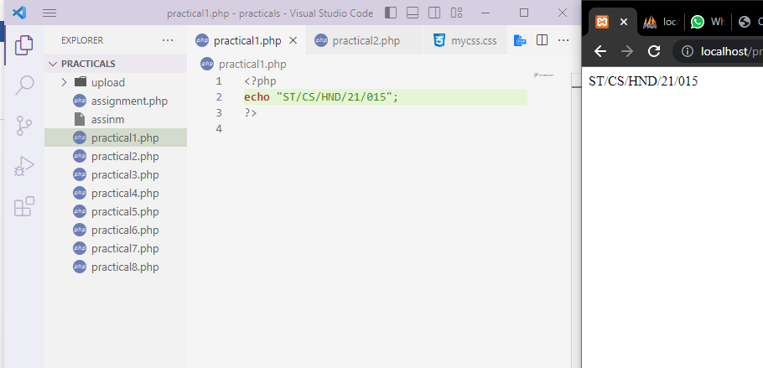

**PRACTICAL TWO**

**CODE**

**Using foreach loop**

**CODE AND OUTPUT**

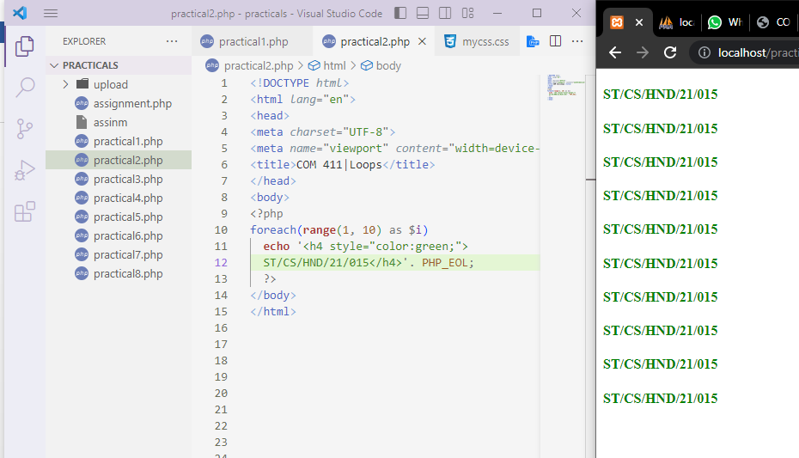

**PRACTICAL THREE**

**CODE**

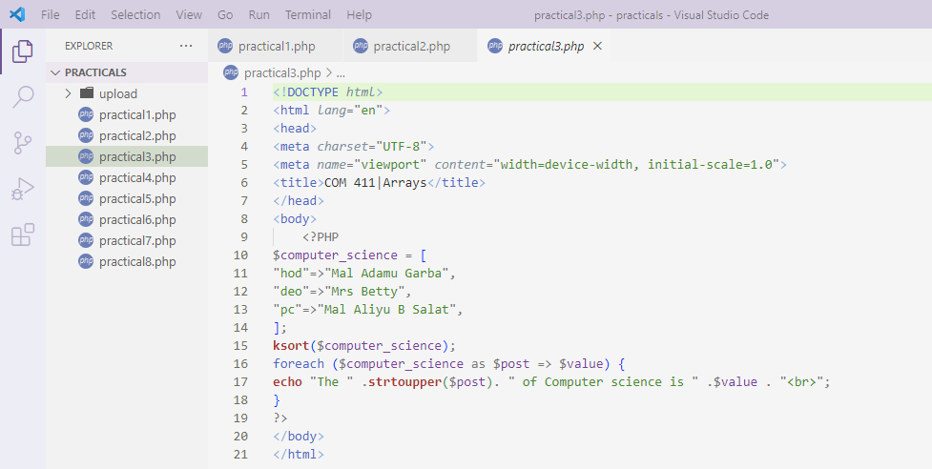

**OUTPUT**

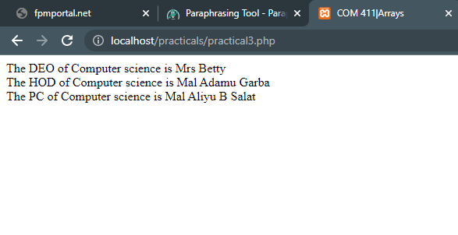

**PRACTICAL FOUR**

**CODE**

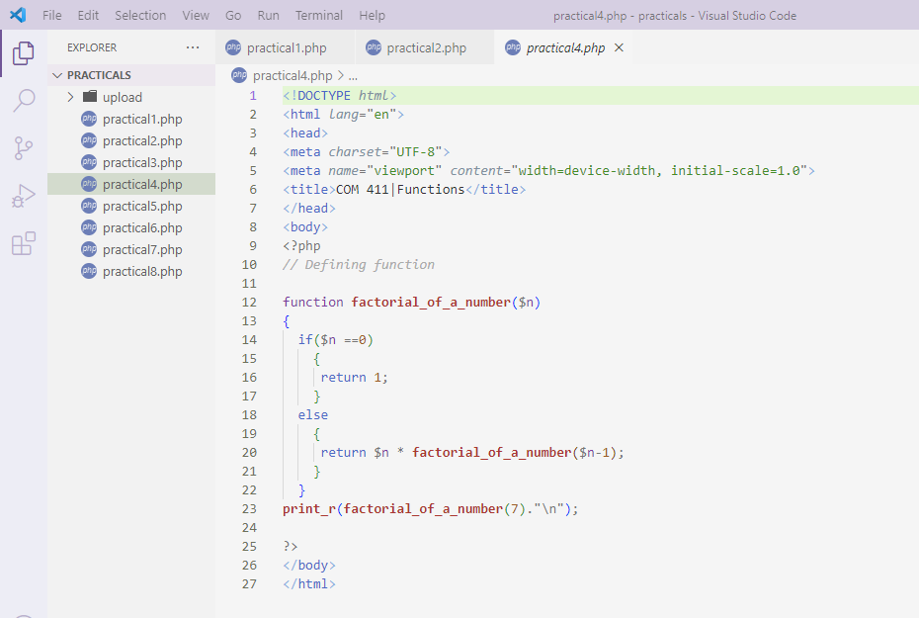

**OUTPUT**

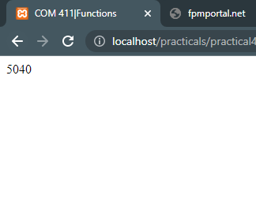

**PRACTICAL FIVE**

**CODE**

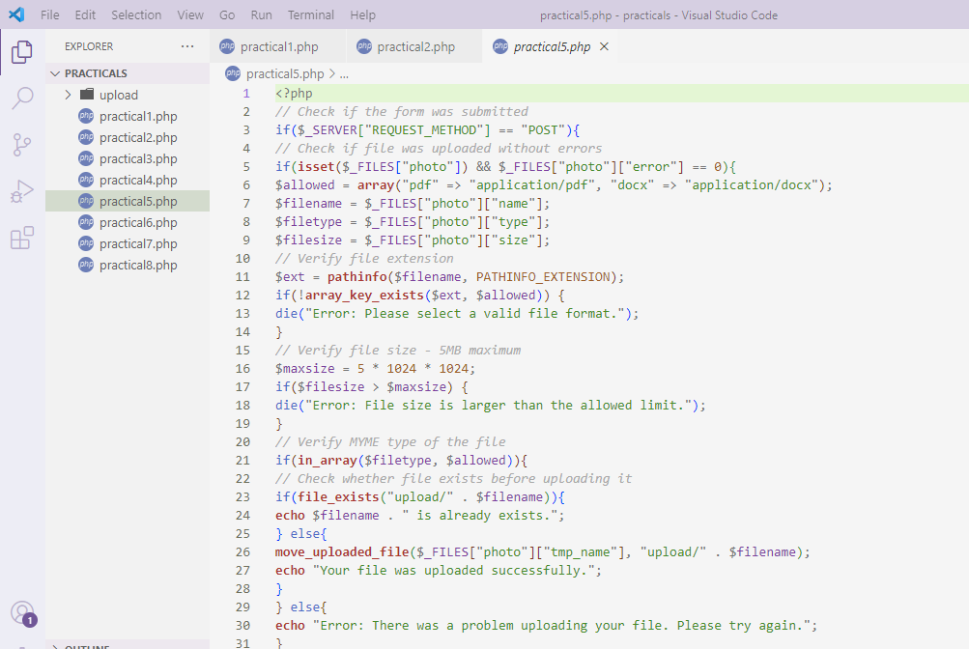

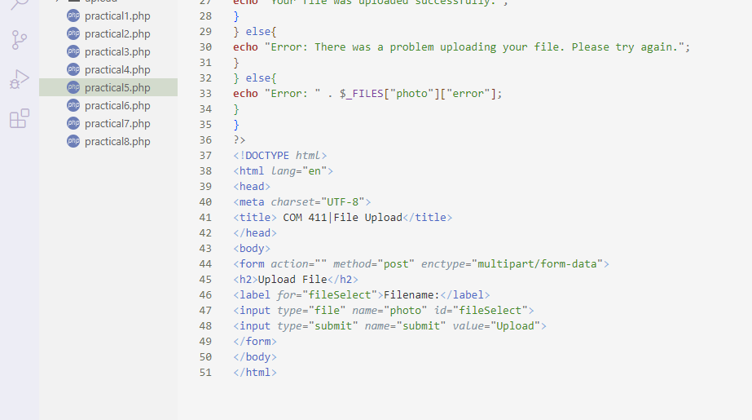

**OUTPUT**

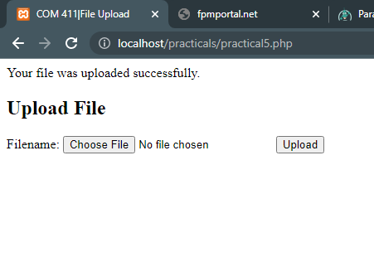

**PRACTICAL SIX**

**CODE AND OUTPUT**

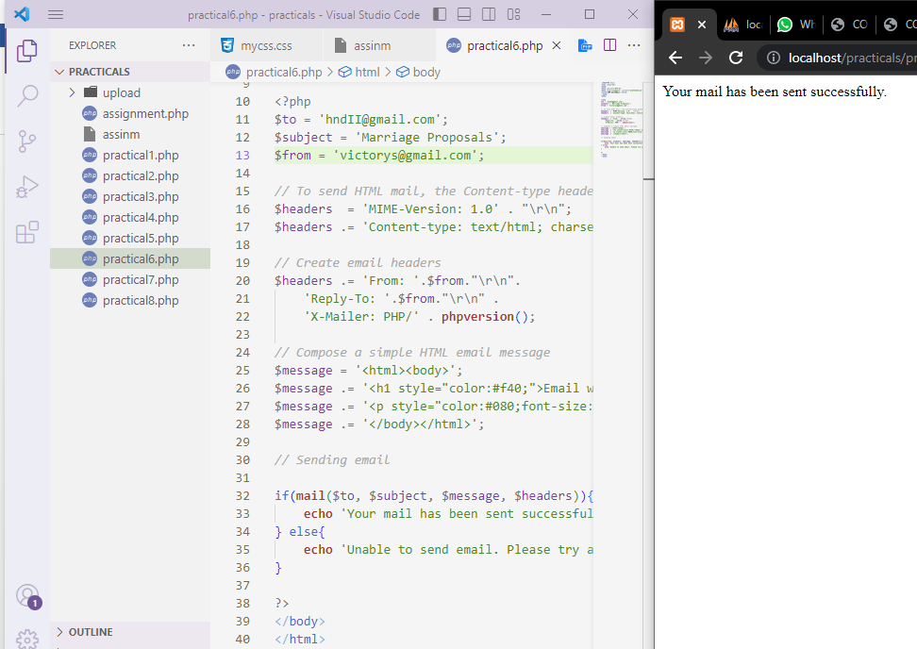

**PRACTICAL SEVEN**

**CODE. OUTPUT AND DB SCREENSHOT**

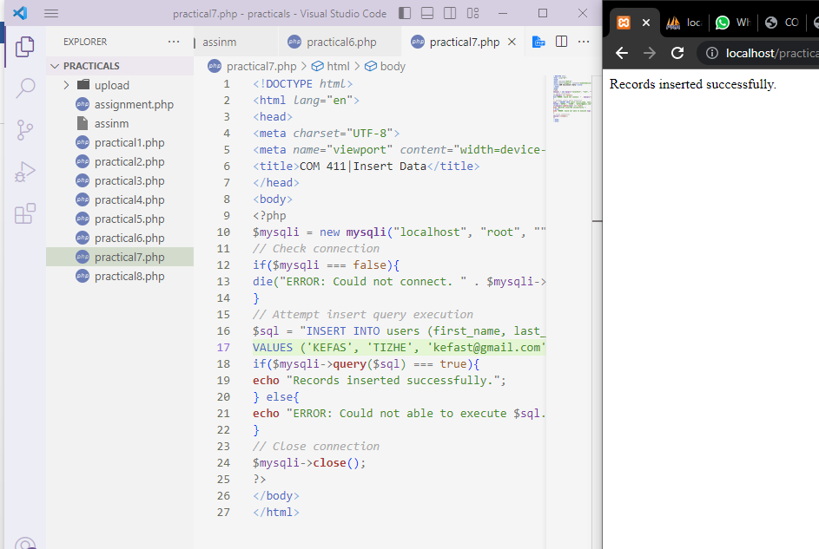

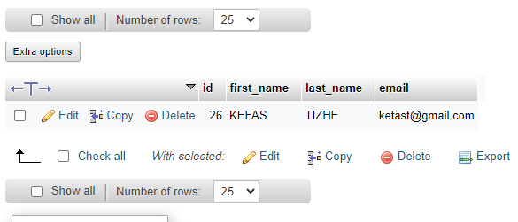

**PRACTICAL EIGHT**

**CODE**

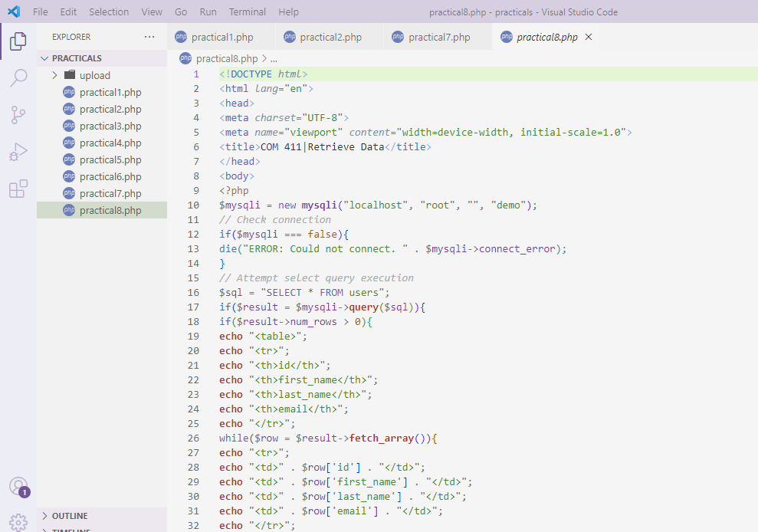

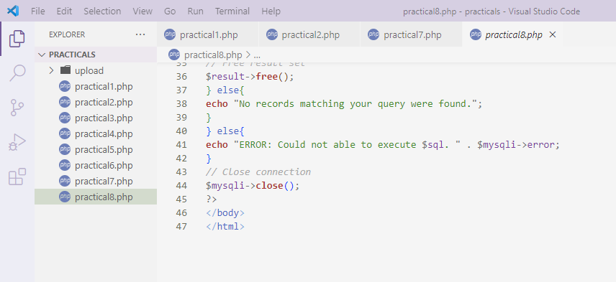

**OUTPUT**

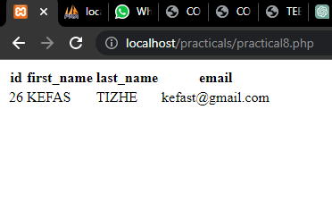

**OTHER NOTES**

**PR. 1**

i) localhost:  is a hostname that refers to the computer that is executing a program

ii) echo: outputs one or more strings

iii) <?php and ?> : These are called PHP's opening and closing tags. Statements witihn these two are interpreted by the parser.

**PR. 2**

1. States the syntax for **for** loop

for (*init counter; test counter; increment counter*) {  
  *code to be executed for each iteration;*  
}

1. Name two (2) other loops that can be use to archive the same goal.
2. Foreach loop
3. Do while loop

**PR. 3**

i) ksort(): used to sort an array in ascending order according to its key values

ii) krsort():  sorts an associative array in descending order, according to the key.

**PR. 4**

1. Differentiate between function that receive parameter and function that does not

A function with argument, as in function(something) is to return a value after processing within the function. A function with no argument, eg function(), is to perform a task with no value returned. In this case, the function acts like a procedure.

**PR. 5**

i) $_FILES["photo"]["name"] : This array value specifies the original name of the file, including the file extension.

ii) $_FILES["photo"]["type"] : This array value specifies the MIME type of the file.

iii) $_FILES["photo"]["size"] : This array value specifies the file size, in bytes

iv) $_FILES["photo"]["tmp_name"] : This array value specifies the temporary name including full path that is assigned to the file once it has been uploaded to the server.

v) $_FILES["photo"]["error"] : This array value specifies error or status code associated with the file upload, e.g. it will be 0, if there is no error.

**PR. 8**

i) fetch_array() : fetches a result row as an associative array, a numeric array, or both.

ii) num_rows : Returns the number of rows in the result set

iii) query() : performs a query against a database.